Online Safety Newsletter

March 2024

Managing Screen time from Internet Matters

Are you worried your child has too much screentime or would like more advice on how to support your child in managing their screen time? Internet Matters have a wealth of information on their website to help support you.

This first link discusses how to get the most out of screen time and how to talk to your child about screen time based on their age:
- https://www.internetmatters.org/issues/screen-time/protect-your-child

This second link provides advice on how to tackle too much screen time and what the signs of too much screen time might be:
- https://www.internetmatters.org/issues/screen-time/deal-with-it/

This final link provides a guide on how to balance screen time:
- https://www.internetmatters.org/resources/creating-a-balanced-digital-diet-with-screen-time-tips/

Fortnite Battle Royale
Fortnite Battle Royale is rated PEGI 12 because it features moderate violence which means it is not suitable for persons under 12 years of age.

It is important to remember that when rating games, PEGI do not take into consideration the communication features of a game. Fortnite does include a chat facility, which adds further risks.

What is Fortnite?
There are different versions of Fortnite, including Battle Royale, which is free to play (although in-app purchases are available). In Battle Royale up to one hundred players compete against each other.

What do I need to be aware of?
- Chatting to strangers and inappropriate language: Fortnite contains voice and text chat. Due to the nature of the game, your child may be chatting to strangers and may hear inappropriate language. Ensure your child knows how to report players for any inappropriate behaviour.
- In app purchases: All users can purchase V-Bucks directly through the game so make sure you don’t store your card details within the game/device and restrict purchases.

Parental Controls
Fortnite includes several parental controls to help you make it a safer environment for your child including disabling voice chat, filtering language and setting privacy settings. Also, remember to set up age-appropriate parental controls on the device your child is playing on.

Further information
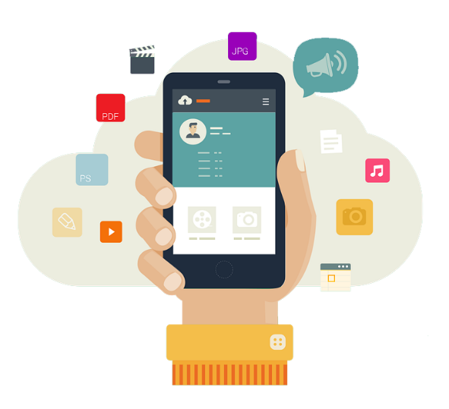
Virgin Media outline how to set up the different parental controls available: https://www.virginmedia.com/blog/parental-controls/gaming-fortnite
Does your child need a mobile phone?

If you are thinking about giving your child their own phone, then you might find this article from Family Lives useful as it discusses things you need to consider:

https://www.familylives.org.uk/advice/primary/health-and-development/does-your-child-need-a-mobile-phone

Users of this guide do so at their own discretion. No liability is entered into. Current as of the date released 01.03.24.

Do you need help managing your child’s device?

You can use Google Family Link or Apple Family Sharing to help you depending on your child’s device.

Google Family Link
This is a parental control app from Google that lets you:
- See activity reports showing how long they spend on each app.
- Approve or block new app downloads.
- Set screen time limits.
- Find their location (using their device).

You will need to download an app and then decide appropriate settings.

https://families.google.com/familylink

Apple Family Sharing
You can set up Family Sharing in the settings of your device. Family Sharing allows you to:
- Share Apple subscriptions.
- Share purchases from the App Store.
- Approve what children purchase/download.
- Limit screen time.
- Share locations and find devices.

https://www.apple.com/uk/family-sharing/

Monitoring Apps (paid for)
In addition, there are apps that you can pay for that you may find provides a better solution for you. Whilst we cannot recommend a specific product, these are some examples that you could review and test using a free trial:
- Norton Family: https://uk.norton.com/products/norton-family
- Qustodio: https://www.qustodio.com/en/
- Family Time: https://familytime.io/

Instagram
You will probably know that Instagram is used to post photos and videos, but did you know that it can also be used to message, voice/video call and send disappearing messages? Users can also upload to ‘Stories’ (which disappear after 24 hours), broadcast live and upload reels (short videos).

You must be over 13 years of age to set up an account. To create an account, you must enter a date of birth (but it is not verified). When you set up an account for users under 16 years old, the account is set to Private. This is the recommended setting so that your child approves who follows them and sees their content. Even if your child’s profile is private, their bio (at the top of their profile) can still be seen by everyone. Check they have not included personal information here e.g. they should not be wearing their school uniform in their photo.

Instagram includes several privacy settings, so go through these with your child and ensure they are set appropriately. Settings include:
- Messages/Group chats – set who can message you/add you to groups.
- Story replies – you can turn this off or choose who can message you.
- Hidden words – turn this option on to hide comments/messages that may be offensive. You can also add your own custom words or emojis.

Make sure your child understands that there is a risk that content they upload can be shared with others without their permission as other users can screenshot it.

Supervision
You can set up supervision on your child’s (aged 13-17) Instagram account. This gives you access to a set of tools including the ability to see who they follow/who follows them, how much time they are spending on Instagram, set a time limit and view accounts your child has blocked. Your child can also share when they have reported anything to Instagram with you. Learn more here: https://help.instagram.com/658522825492278

Safety Features
Ensure your child knows how to report posts and people, how to unfollow and block people, delete and turn off comments. View here: https://help.instagram.com/269765046710559

Quiet mode
Your child can activate quiet mode, so they do not receive notifications (to provide less distraction whilst studying and at night time).

How can I keep my child safe on Instagram?
The NSPCC have published a blog with everything that you need to know:
https://www.nspcc.org.uk/keeping-children-safe/online-safety/online-safety-blog/keeping-children-safe-on-instagram/

More information
- Visit the family centre to learn more about the features available: https://familycenter.instagram.com/
- Download a parent's guide to Instagram: https://help.instagram.com/299484113584685

